温度转换

#include<iostream>

using namespace std;

int main(){

double C, F;

cin >> C;

F =C\*9/5+32 ;

cout << "摄氏温度C=" << C << endl;

cout << "华氏温度F=" << F << endl;

}

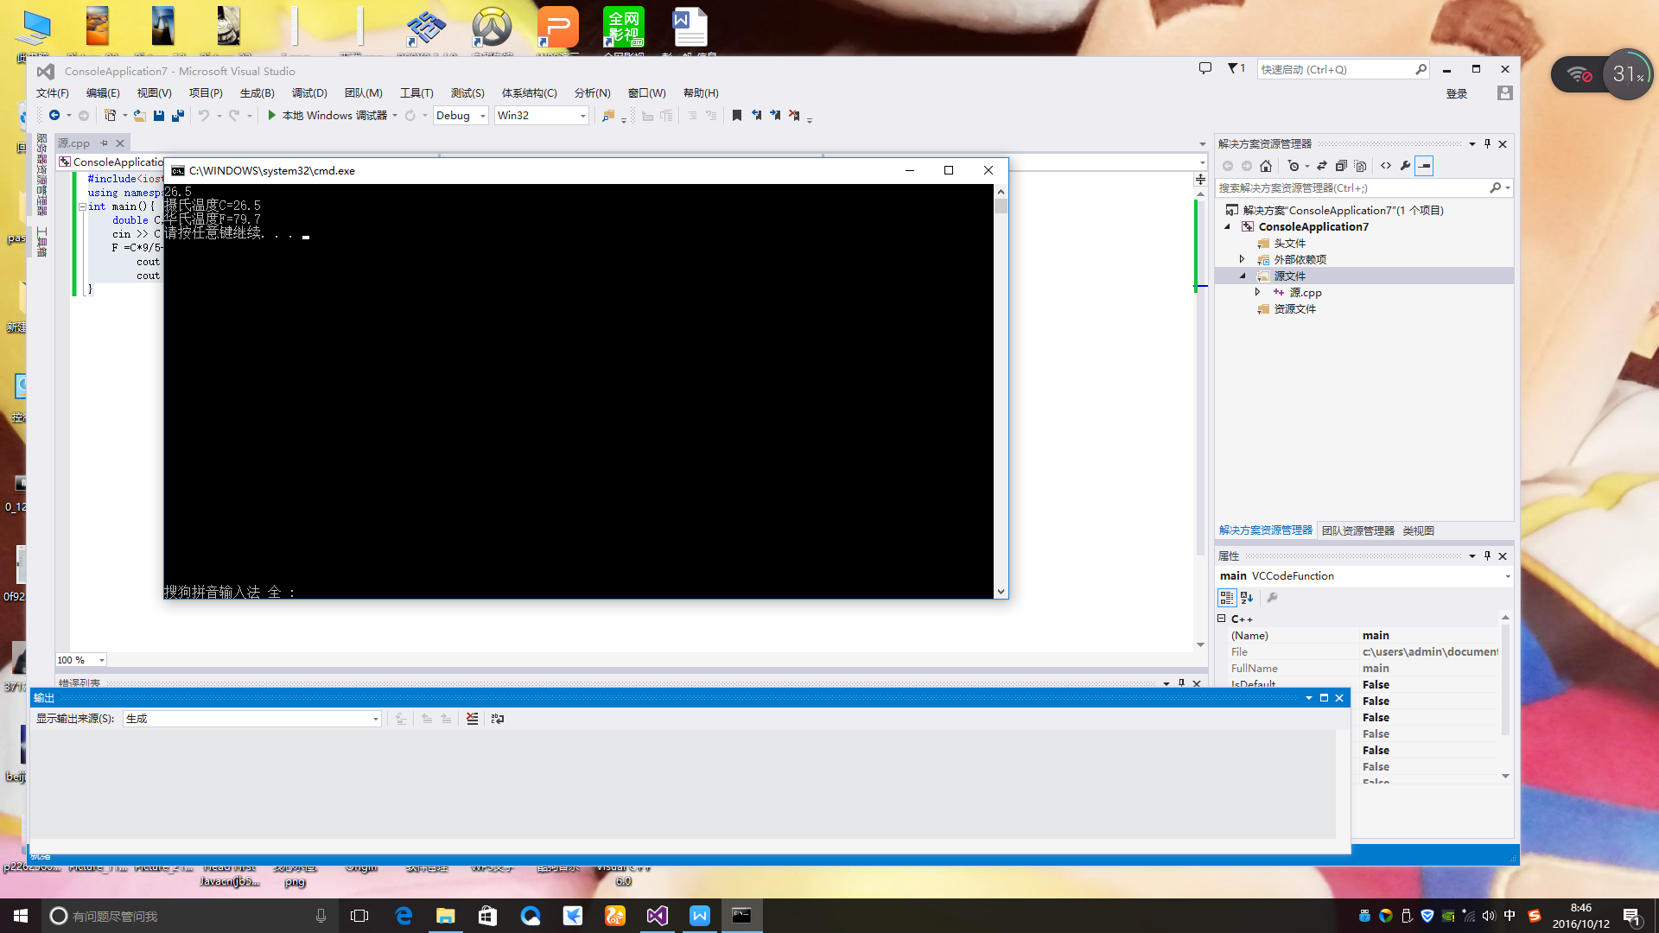

字节

#include<iostream>

using namespace std;

int main(){

cout << "char=" <<sizeof(char)<< endl;

cout << "short int=" << sizeof(short int) << endl;

cout << "int=" << sizeof(int) << endl;

cout << "long int=" << sizeof(long int) << endl;

cout << "double=" << sizeof(double) << endl;

cout << "long double=" << sizeof(long double) << endl;

}

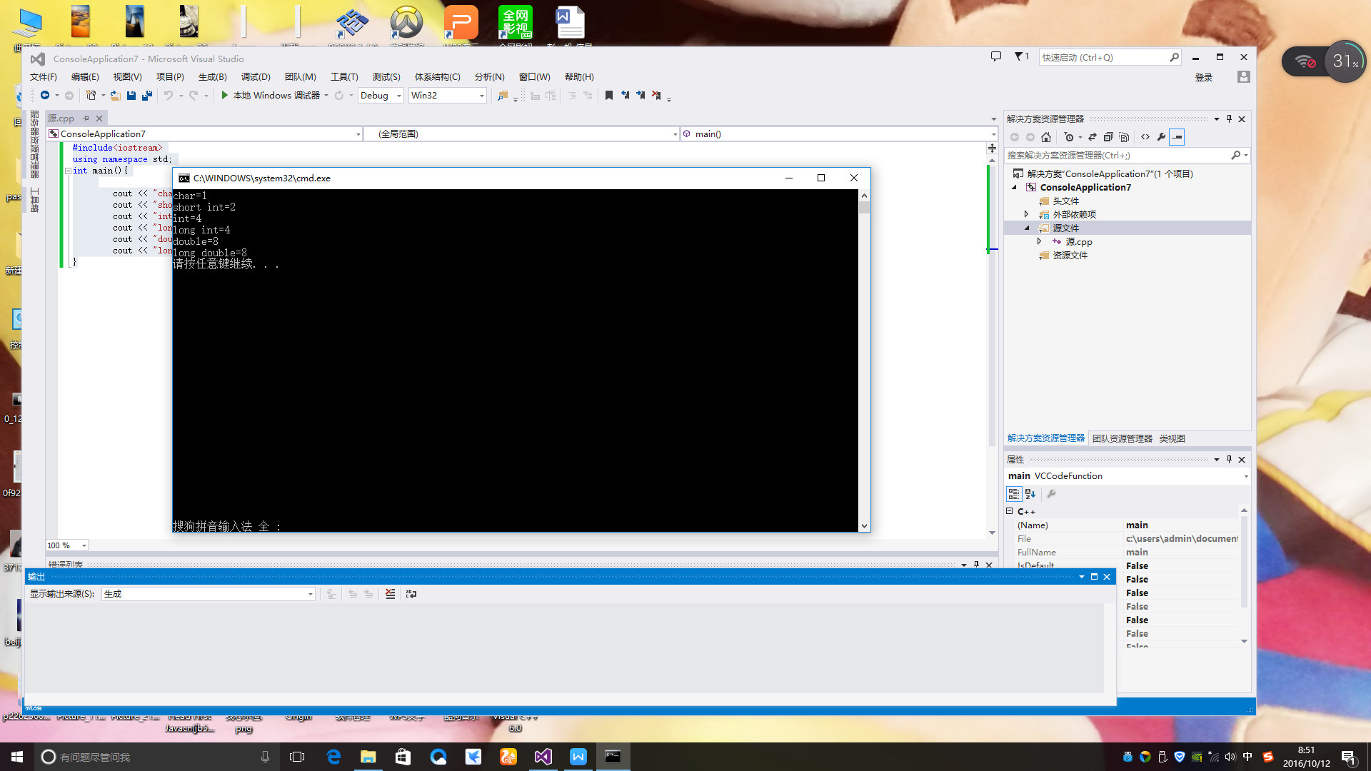

平方和立方

#include<iostream>

using namespace std;

int main(){

int a = 0, b = 1, c = 2, d = 3, e = 4, f = 5, g = 6, h = 7, i = 8, j = 9, k = 10;

int a1, b1, c1, d1, e1, f1, g1, h1, i1, j1, k1;

int A, B, C, D, E, F, G, H, I,J,K;

a1 = a\*a; b1 = b\*b; c1 = c\*c; d1 = d\*d; e1 = e\*e; f1 = f\*f; g1 = g\*g; h1 = h\*h; i1 = i\*i; j1 = j\*j; k1 = k\*k;

A = a1\*a; B = b1\*b; C = c1\*c; D = d1\*d; E = e1\*e; F = f1\*f; G = g1\*g; H = h1\*h; I = i1\*i; J = j1\*j; K = k1\*k;

cout << "原数" << "\t" << "平方" << "\t" << "立方" << endl;

cout << "0" << "\t" << a1 << "\t" << A << endl;

cout << "1" << "\t" << b1<< "\t" << B << endl;

cout << "2" << "\t" << c1 << "\t" << C << endl;

cout << "3" << "\t" << d1<< "\t" << D << endl;

cout << "4" << "\t" << e1 << "\t" << E << endl;

cout << "5" << "\t" << f1 << "\t" << F << endl;

cout << "6" << "\t" << g1 << "\t" << G << endl;

cout << "7" << "\t" << h1 << "\t" << H << endl;

cout << "8" << "\t" << i1 << "\t" << I << endl;

cout << "9" << "\t" << j1 << "\t" << J << endl;

cout << "10" << "\t" << k1 << "\t" << K << endl;

}

